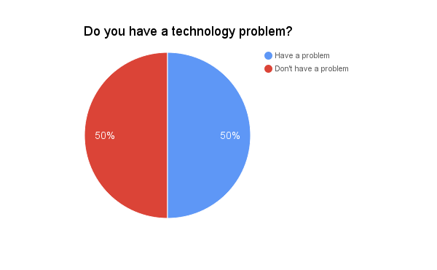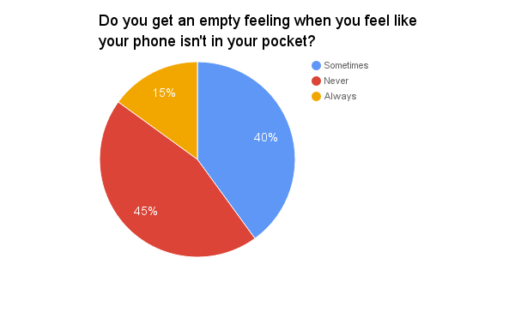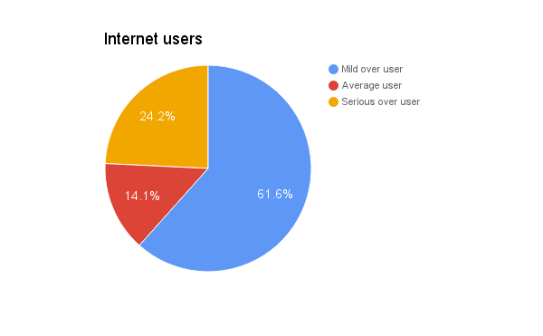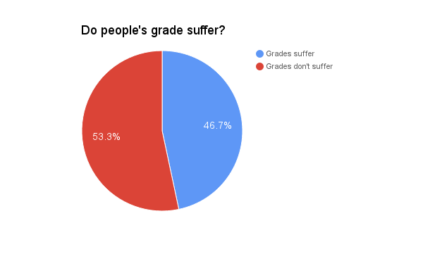

About half of the US’s population is affected by this.

- Teenager lead with the most % of people suffering with and addiction with 73% addicts.

- People who suffer with this addiction often neglect friends and family members.

- Technology addiction is most likely to surface in the patient’s teenage years

- Nowadays, people are interacting with each other via social media networks such as Twitter, Facebook, Instagram, and Snapchat.

- Mental effects: Feelings of guilt, Depression, Anxiety, Dishonesty, and a euphoric feeling when in front of a computer.

- Health effects: Backache, Headaches, Weight gains or loss, Disturbance in sleep, Carpal tunnel syndrome and blurred and strained vision.

- Escitalopram is a drug option that has been shown to be effective for Internet addiction, according to studies School of Medicine at Mount Sinai

- reSTART life is a 45-day retreat program where patients “disconnect and find themselves” at reSTART costs $20,000 and further treatment is $421 a day.

- At this day and age, children around the age of 2 are using technology.

- Rehabilitation centers in the USA: the Center for Internet Addiction, in Bradford, Pennsylvania, The Center for Internet and Technology Addiction in West Hartford, Connecticut and ReSTART Internet Addiction Recovery Program in Fall City, Washington.

