A survey was taken in a high school environment, the subjects were students in the tenth grade, they were asked if they have ever in their life smoked nicotine or have vaped.
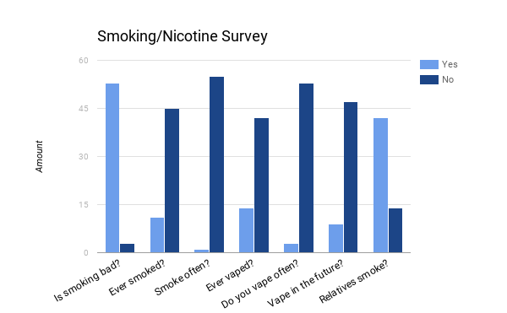

Questions and Answers:
- What is the estimated number of people who are afflicted with this addiction in the United States? What about locally?
-In the U.S 16 million people suffer with illness caused by smoking. -www.drugbuse.gov
- What age group are most likely to suffer from this addiction?
- 18-24 year olds are most likely to smoke. -www.cdc.gov/tobacco
- What socioeconomic factors may contribute to this addiction rate?
-Local resources are used to help people.
- When is this addiction most likely begin to surface?
-Depends on what the addiction might be.
- How long does this addiction last, and/or what is the rate of relapse in those with this addiction?
-Nicotine symptoms reach their peak 2 to 3 days after you quit and are gone with in/to three months. It takes 3 months for your brain chemistry to return to normal. www.addictionsandrecovery.org/quit-smoking-plan.htm

- Is this addiction treated at a rehabilitation facility and/or what is the average amount of return or to this rehab facility for further treatment?
-Smoking can be treated in the U.S.
- Can people with this addiction live a seemingly functional existence.
-Smoking can be cured and make a big difference to your health. Ex; If you stop smoking at a middle age, before having cancer, you just avoided a risk of death.
- Is this addiction likely to disrupt or prevent a functional existence?
-Smoking while pregnant can harm a newborn, increasing the baby to bor early or low birth weight. - www.nebi.nml.nih.gov/pmc/articles/pmc26568111
- Does this addiction have a connection to or for a family history?
-For many people that “someone” is a family member. It could be your mom, dad, aunt, uncle, sibling, or grandparent. Regardless of who it is, there's no doubt it had an impact on your life.
- Is there a connection between this addiction and childhood or family abuse, either by the addicted or the victims of the abuser?
-80% of offenders abuse drugs or alcohol.Nearly 50% of jail and prison inmates are clinically addicted. Approximately 60% of individuals arrested for most types of crimes test positive for illegal drugs at arrest.
- What are the effective treatments are available for this addiction?
-The effective treatments that are available for tobacco addiction are nicotine replacement treatment, additional medications and behavioral treatment.
- What are the personal costs of supporting this addiction?
-The personal costs of supporting this addiction is roughly around $2160 a year on cigarettes, while for alcoholic it is only $432 a year for bear, and cocaine or heroin which is $10,000 a year.
- What are the costs of treatments for this addiction?
-In the US the treatment costs round up to 133 dollars in the US.
- Notable people/historical figures that have suffered from this addiction are?
-There are Benjamin Franklin, Elvis Presley, Thomas Edison, Adolf Hitler, Marylin Monroe, etc.
- What mental issues could contribute to or affect this addiction
- The biological factors involved in smoking relate to how the brain responds to nicotine. When a person smokes, a dose of nicotine reaches the brain within about ten seconds. At first, nicotine improves mood and concentration, decreases anger and stress, relaxes muscles and reduces appetite. Regular doses of nicotine lead to changes in the brain, which then lead to nicotine withdrawal symptoms when the supply of nicotine decreases. Smoking temporarily reduces these withdrawal symptoms and can therefore reinforce the habit.

- What physical or health related side effects might this addiction cause?
-Smokers have a higher risk of respiratory infections, colds, and flu. Smoking raises the risk of forming blood clots. These problems can lead to tooth decay, tooth loss, and bad breath. These problems can lead to tooth decay, tooth loss, and bad breath.

- What is the fatality rate of those diagnosed with this addiction?
- According to the Centers for Disease Control and Prevention (CDC), cigarette smoking results in more than 480,000 premature deaths in the United States each year—about 1 in every 5 U.S. deaths—and an additional 16 million people suffer with a serious illness caused by smoking.
- What specific addiction problems are most prevalent in our local community?
- Drug abuse is a major public health problem that impacts society on multiple levels. Directly or indirectly, every community is affected by drug abuse and addiction, as is every family. Drugs take a tremendous toll on our society at many levels.

(FOR THE TENTH GRADERS)
Is smoking bad for you?
Yes: 53 No: 3
Have you ever smoked?
Yes: 11 No: 45

If yes, do you smoke often?
Yes: 1 No: 55
Have you ever used a vape pen?
Yes: 14 No: 42
Do you vape often?
Yes: 3 No: 53
Will you be smoking in the future?
Yes: 9 No: 47
Do you have any relatives that smoke?
Yes: 42 No: 14

Cigarette smoking kills more than 480,000 Americans each year, with more than 41,000 of these deaths from exposure to secondhand smoke. In addition, smoking-related illness in the United States costs more than $300 billion a year, including nearly $170 billion in direct medical care for adults and $156 billion in lost productivity. In 2014, an estimated 16.8% (40.0 million) U.S. adults were current* cigarette smokers. Of these, 76.8% (30.7 million) smoked every day, and 23.2% (9.3 million) smoked some days.
Race/Ethnicity | Prevalence
American Indian/Alaska Natives (non-Hispanic) | 29.2%
Asians (non-Hispanic) | 9.5%
Blacks (non-Hispanic) | 17.5%
Hispanics | 11.2%
Multiple Races (non-Hispanic) | 27.9%
Whites (non-Hispanic) | 18.2%

Age | Prevalence
18–24 years | 16.7%
25–44 years | 20.0%
45–64 years | 18.0%
65 years and older | 8.5%

Income Status | Prevalence
Below poverty level | 26.3%
At or above poverty level | 15.2%

